Project Design Phase
Problem – Solution Fit Template
Date: 15 February 2025
Team ID: __________
Project Name: DarshanEase
Problem – Solution Fit
Problem 1:
Devotees face long waiting times and difficulty in getting darshan tickets at temples.
Solution:
DarshanEase provides an online platform where users can view temple details, check available darshan slots, and book tickets easily.
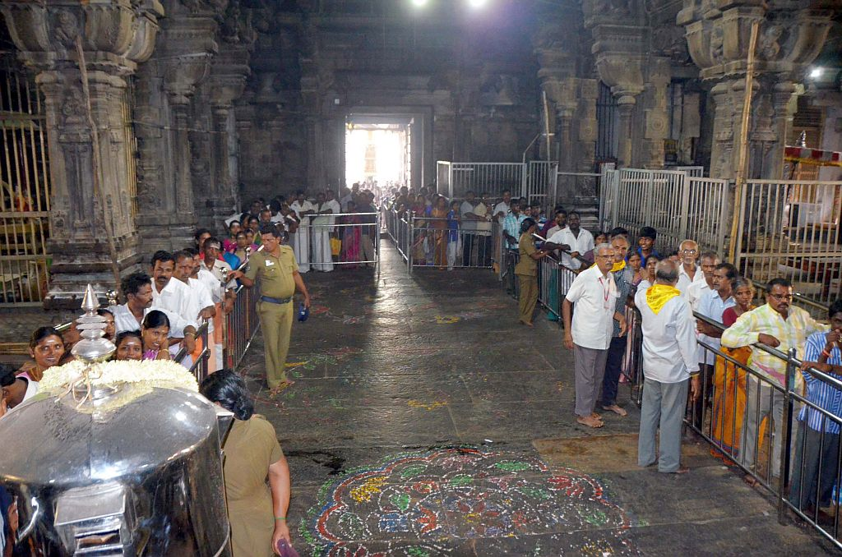
This Photo by Unknown Author is licensed under CC BY
Problem 2:
Visitors do not know the availability of darshan timings before visiting the temple.
Solution:
The application shows available time slots and allows devotees to select their preferred darshan time.
Problem 3:
Temple administrators face difficulties in managing visitor bookings manually.
Solution:
DarshanEase helps administrators manage bookings digitally and maintain visitor records efficiently.
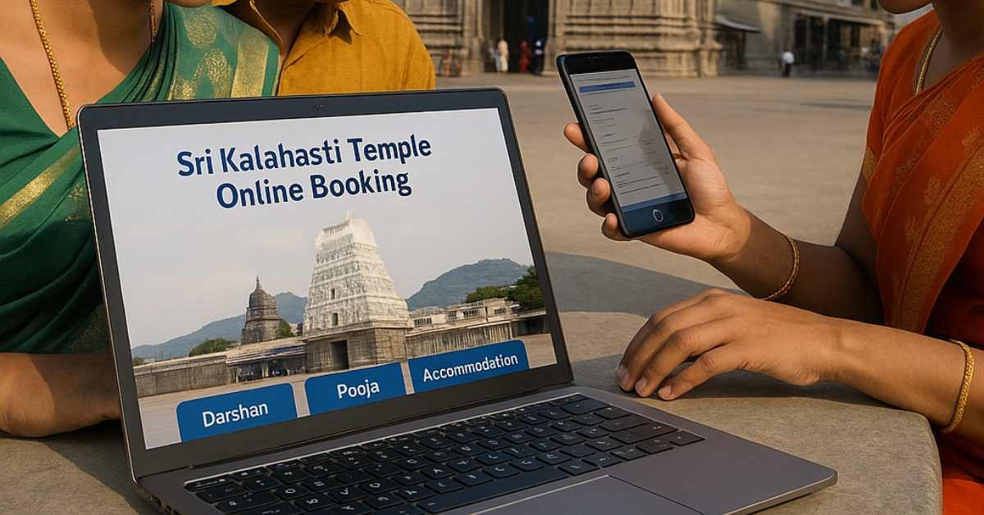
Problem 4:
Manual booking processes cause errors and waste time.
Solution:
The MERN-based application provides a simple, secure, and organized online booking system.
Target Customers:
Temple devotees/visitors
Temple administrators
Existing Situation:
Long queues at temples
Difficulty finding booking information
Manual management of bookings
Proposed Solution: DarshanEase is a full-stack web application that allows devotees to book darshan slots online and helps temples manage bookings efficiently

